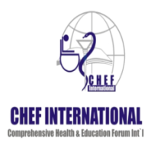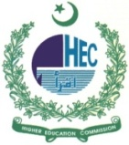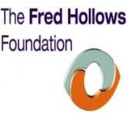
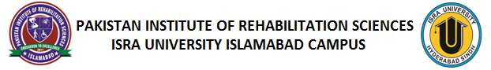
Public Health Planning for Hearing Impairment – Islamabad
“Planning today for a better tomorrow”
Public health planning for hearing impairment is one of the critical dimension in both the ear & hearing health system and the ear & hearing health program in Pakistan. It is not only important for developing the health plans and programs responsive to the needs of population, but it is also vital for budgeting and resource allocation in a systematic and equity sensitive manner.
Why public health planning for hearing impairment? 360 million people worldwide have disabling hearing loss (5.3% of the world’s population), out of which 32 million (9%) are children. 80% live in low and middle income countries like Pakistan. Fortunately, most causes of hearing loss are either preventable or treatable. Hearing loss in Pakistan accounts for 7% to 8%, if planning not made in time, it will add further in to disabilities in Pakistan.
To address this cause, Pakistan Institute of Rehabilitation Sciences (PIRS) Islamabad & London School of Hygiene & Tropical Medicine (LSHTM) UK, joined hands together to take a step forward to develop a “National Program for Ear & Hearing Health Care in Pakistan” like –wise “National Program for the Prevention & Control of Blindness in Pakistan”. A short course of five days was developed after struggles for several years made by Dr. Babar Qureshi (Ex-CEO CHEF International) & Prof. Dr. Andrew Smith (Course Director – LSHTM) on “Public Health Planning for Hearing Impairment” at Ramada International Hotel, Islamabad, Pakistan from 14th to 18th December 2015 under the leadership of Dr. Farrukh Seir (Executive Director – PIRS).
Aim of this course was “to understand the magnitude and causes of hearing impairment in Pakistan and develop not only a public health approach but human rights approach for developing ear & hearing health program in Pakistan.
Objectives of the course was how to apply principles of public health to hearing loss in Pakistan, & to look in to the solutions for the prevention, control & rehabilitation of hearing impaired persons in Pakistan. Integration of Primary Ear & Hearing Health Care in to existing Primary Health Care Centers (Community Health Centers / Community Vision Centers) like primary eye care in Pakistan to be assessed & should be made possible.
Participants of the course were of different disciplines i-e ENT Specialists, Audiologists, Public Health Specialists, Epidemiologists, and Speech & Language Therapists etc.
Course was delivered by the experts from London School of Hygiene & Tropical Medicine and CBM International. Lectures, Interactive discussions, group exercises, question answers, case studies, success stories were made / presented during the course.
International Presenters / Speakers: Prof. Shelly Chadda (Technical Officer – WHO, Switzerland), Prof. Dr. Andrew Smith (Course Director – LSHTM), Dr. Daksha Patel (Course Director – LSHTM), Dr. Sian Tesni (CMB Special Advisor on Education) and Dr. Deigo Santanna Hernandez (CBM Advisor on Ear & Hearing Care).
National Presenters / Speakers: Prof. Dr. Mohammad Daud Khan (Chairman CHEF International), Dr. Maryam Malick (WHO-Pakistan Office), Dr. Sania Nishtar (Chair & Founder - Heartfile) and Prof. Dr. Anjum Khawar (ENT Specialist & National Coordinator – Ear & Hearing Care in Pakistan).
Learning from the course: Hearing impairment is the 2nd leading cause of disability in Pakistan next to Visual impairment – Dr. Haroon Awan, if in time measures are not taken, it will further add in to the disabilities in Pakistan. Lessons learned from National Program for the Prevention of Blindness in Pakistan made us aware of how proper the plan needs to be done that result in effective outcomes. “Coming together is beginning, Keeping together is a process & Going together is the Progress” – Prof. Dr. Mohammad Daud Khan Said. Further, we need to focus on Primary Health Care as the only reason for succeeding in secondary & tertiary health care system. Despite of challenges faced by Pakistan, we still have many success stories & we have make a change now – Dr. Sania Nishtar. 98% of the disables in Pakistan are out of education & we need to use human rights approach to address the hearing impaired persons in Pakistan – Dr. Maryam Malick. To ensure success in Public Health Planning for hearing impairment in Pakistan, setting priorities & cost analysis needs to be done immediately but carefully – Prof. Dr. Andrew Smith. Nothing about us, nothing without us – Dr. Sian Tesni said & emphasized on Literacy & education among hearing impaired persons lead to have better health & better employment opportunities in Pakistan. Primary Health care (PHC) is considered as a nucleus of the health system that leads to overall social & economic development of the community – Dr. Deigo Santanna Hernandez said, PHC is the only way to increase awareness among society regarding hearing impairment. Train others & that’s how we are trained, otherwise we were not being here this time. Careful situational analysis & identifying the gaps appropriately to plan for ear & hearing health care program in Pakistan in order to know what needs to be done, what should be done & what must be done – Dr. Daksha Patel. Public Health planning for hearing impairment in Pakistan will be successful if useful advocacy is developed & implemented at the gross root level – Prof. Shelly Chadda. We need human resource development (ENT, Audiology, Technicians, LHW’s, Nurses etc) to cattle the hearing loss in Pakistan – Prof. Dr. Anjum Khawar. I am quite confident that what the success happened to vision sciences in Pakistan, the same is likely to happen with hearing sciences also – Dr. Farrukh Seir.
Outcomes of the course: Its very unacceptable what is happening today but never let it be tomorrow – Prof. Dr. Mohammad Daud Khan said, this lead to the developing an initiative of “SUNNPAK-2030” for establishing National Program for Ear & Hearing Health Care in Pakistan with the aim to eliminate avoidable hearing loss in Pakistan & to increase awareness among all the citizens. Efforts need to be made to integrate Primary Ear & Hearing Care (PEHC) in to existing Primary Health Care (PHC / CVC’s i-e Community Vision Centers) in Pakistan as like happen to Primary Eye Care (PEC). Course Participants designed & proposed some essential planning for Primary ear & Hearing Health Care, School Ear & Hearing Health Program, Ear & Hearing Health Care at Secondary & Tertiary Levels and Rehabilitation for the ear & hearing impaired among Pakistani community that needs to be imparted & implemented after review from the experts.
Recommendations made during the course: Deaf & Hearing impaired person should have right access to every level of health care. Pakistan needs to train human resources & task force like Audiologists, Technicians, LHW’s etc to control causes of hearing impairment in Pakistan. Develop a standard equipment list of Ear & Hearing Care to meet the minimum requirements for ear & hearing care at all levels of health care. Universal neonatal hearing screening programs need to be initiated across the country. Efforts should be made to develop a standardized curriculum for educating ear & hearing hard people in Pakistan. Pakistan sign language needs to be developed. Higher education for deaf & hearing impaired should be advocated with Higher Education Commission & Pakistani Universities. International linkages & collaborations will be developed with World Health Organization (WHO), World Wide Hearing (WWH), and Coalition for Global Hearing Health, NGO’s, INGO’s, National, Regional & Global institutions / organizations which would help to build the capacity of SUNNPAK-2030.
Program Activities & Highlights
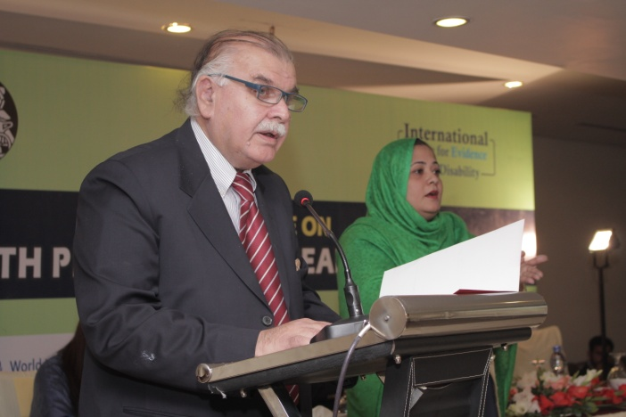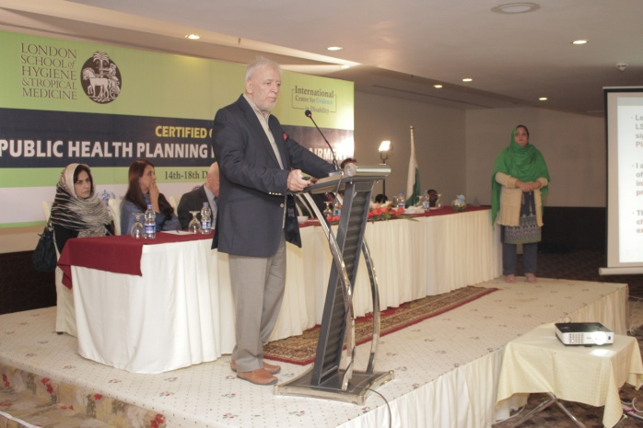
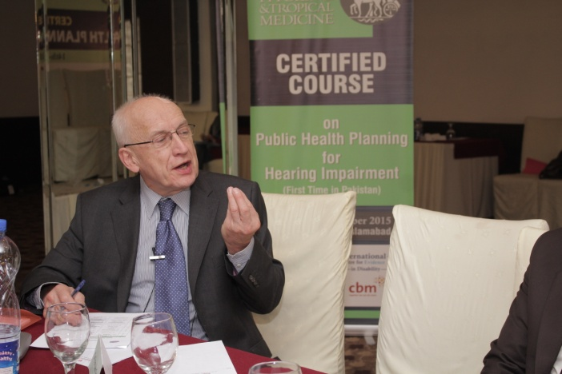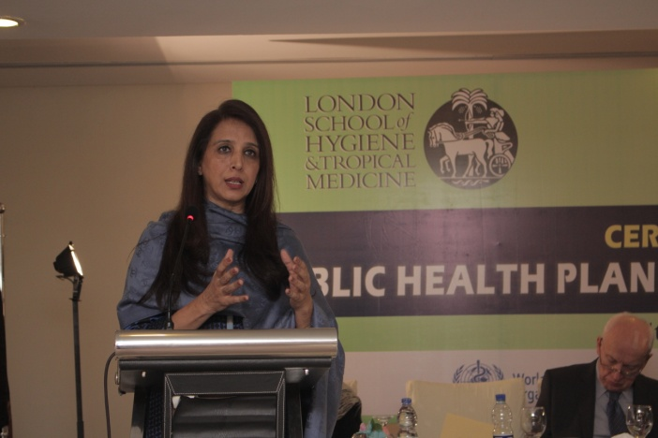
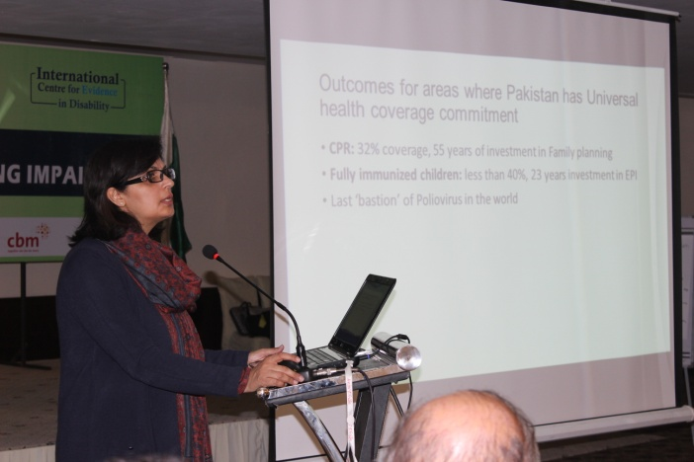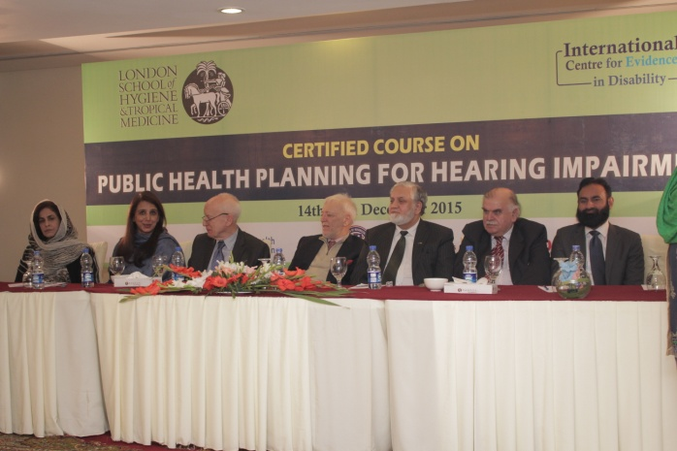
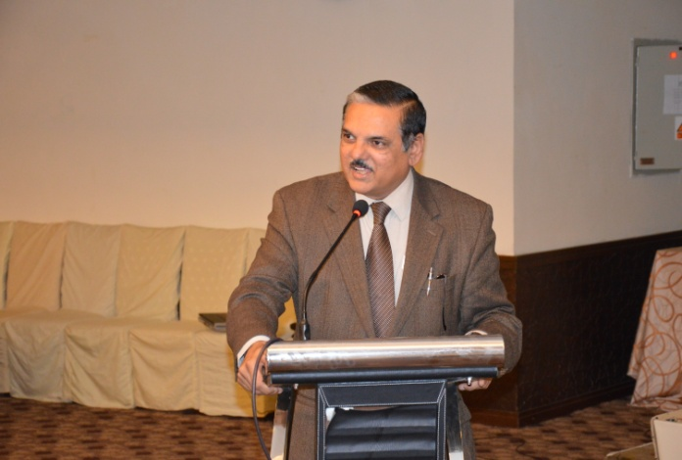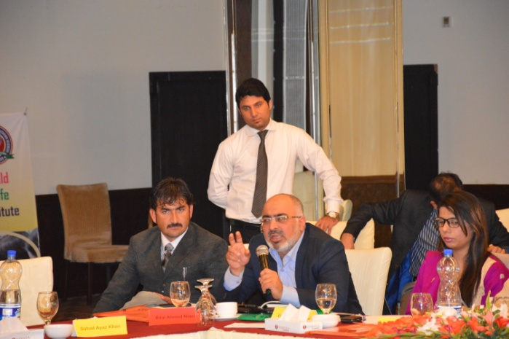
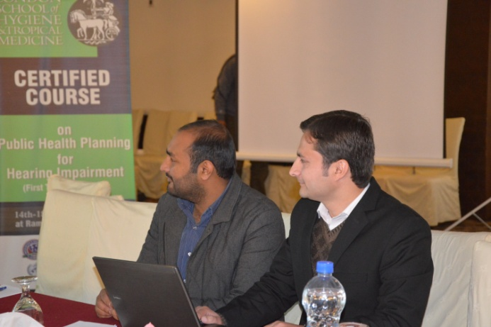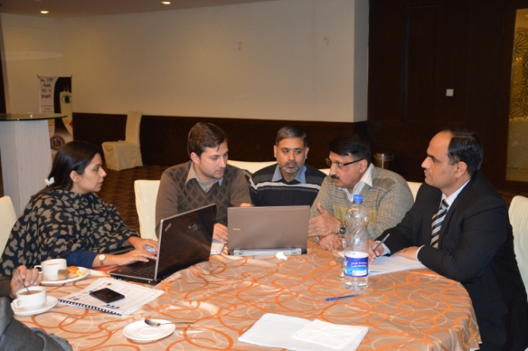
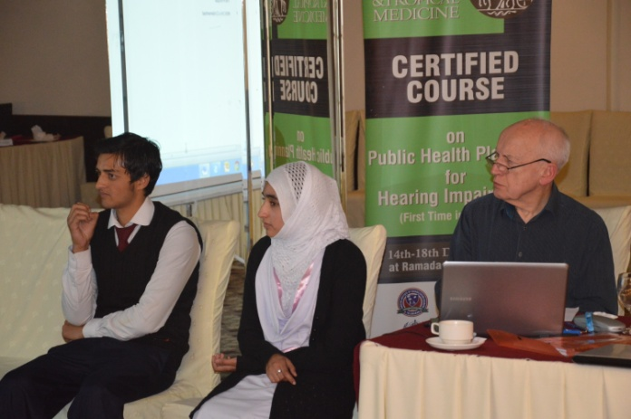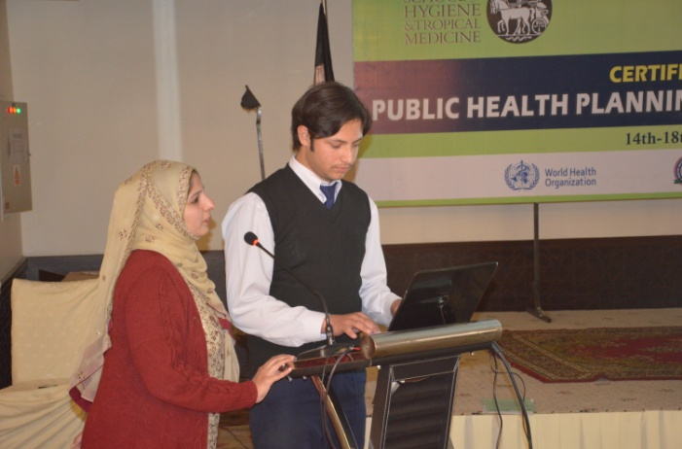
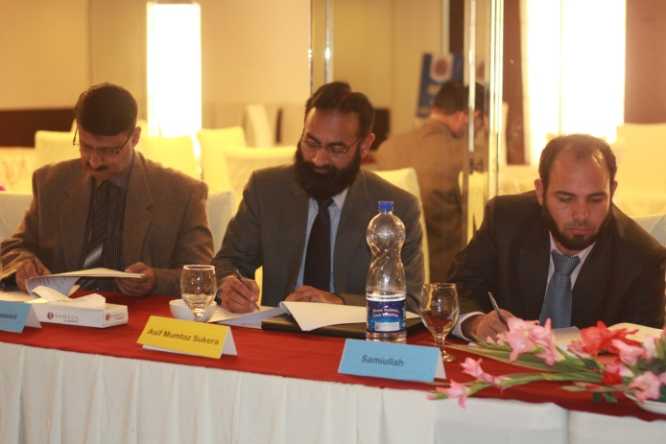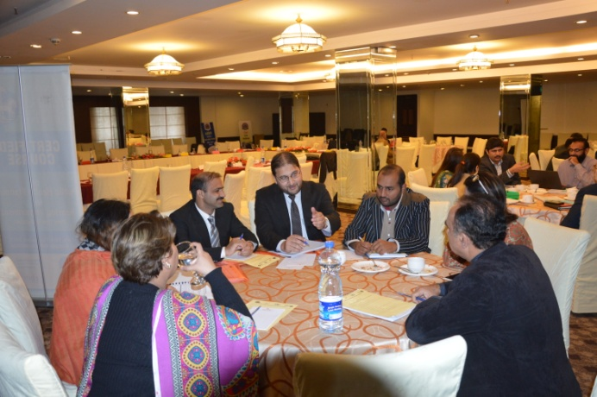
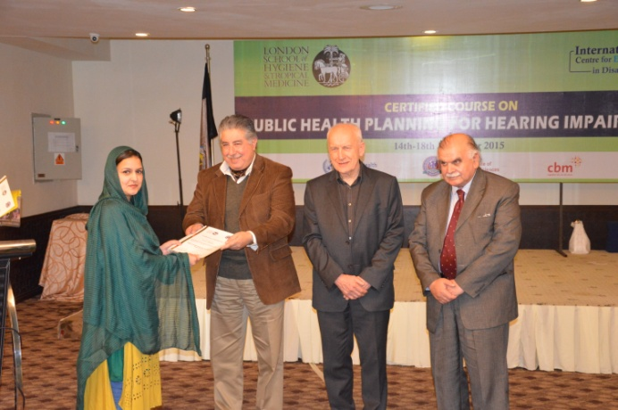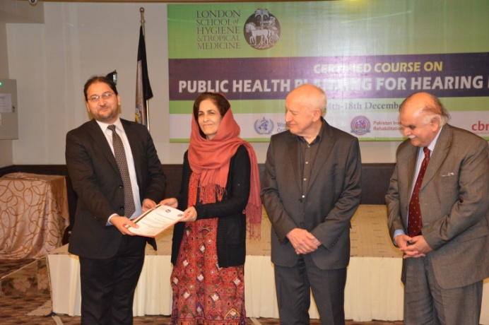
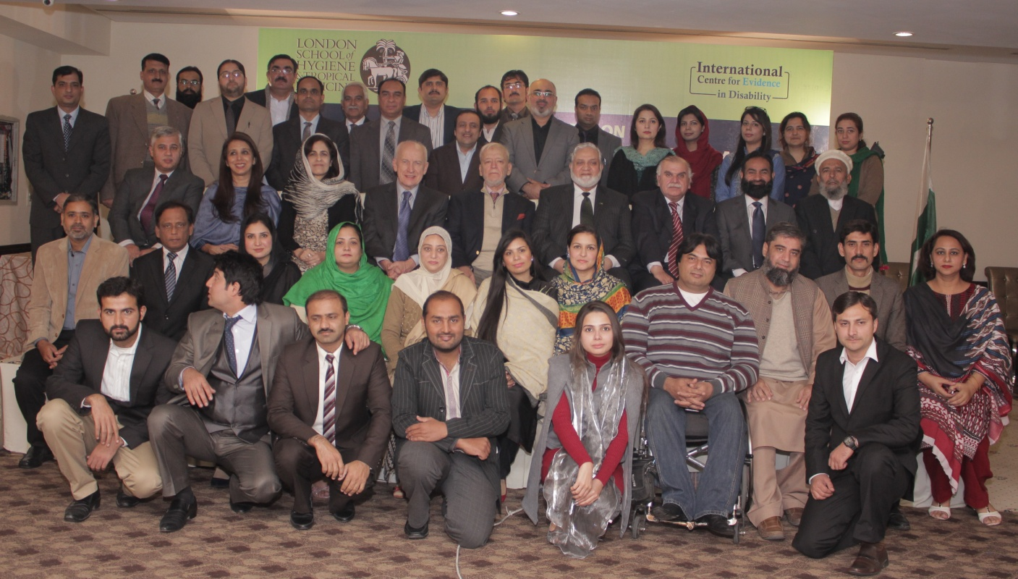

Pakistan Institute of Rehabilitation Sciences (PIRS), Isra University, Islamabad Campus, Lehtrar Road, Farash Town II, Islamabad.

