TEN FACTS ABOUT DEAFNESS & HEARING IMPAIRMENT
1: There are 360 million persons in the world with disabling hearing loss:  This is 5.3% of the world’s population - 32 million of these are children. Disabling hearing loss is defined as:  - Adults (15 years and older): hearing loss greater than 40 dB in the better hearing ear;  - Children (0 – 14 years of age): hearing loss greater than 30 dB in the better hearing ear. | 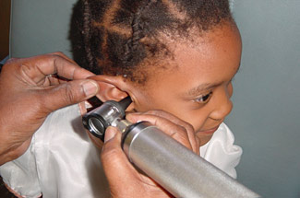
2: Chronic ear infections are a leading cause of hearing loss:  The global prevalence of chronic otitis media (COM) ranges from 1 to 46% in developed and developing countries.  COM leads to hearing loss and can cause life threatening complications and mortality.  COM is largely preventable. It can be managed effectively through medical and surgical means. | 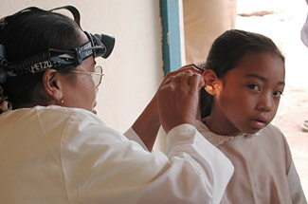

3: Noise is a major avoidable cause of hearing loss:

Noise is a cause for concern in both, developed and developing countries.

In many countries, excessive noise has become the most compensated occupational hazard.

The risk of social noise, such as, music and entertainment devices, is increasing globally among young persons.

4: Hearing loss can be due to the use of ototoxic medications:

Some commonly used medications (such as aminoglycosides, anti-malarial drugs) can lead to irreversible hearing loss.

Ototoxicity can be prevented through awareness amongst health-care providers and rational use of drugs.

5: Approximately 0.5-5 of every 1000 infants is born with or develops in early childhood disabling hearing loss:

Early detection and management is important in providing appropriate support for deaf and hearing-impaired babies

That will help them enjoy equal opportunities in society

6: Nearly one out of every three persons over 65 are affected by hearing loss:  - Left untreated hearing loss affects communication and can contribute to social isolation, anxiety, depression and cognitive decline.  - Age-related hearing loss can be managed effectively through a variety of means, including hearing aids. | 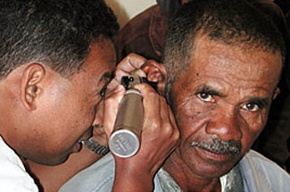

7: 50% of hearing loss is preventable through public health actions:

These include:

- Immunization

- Healthy ear and hearing care habits

- Effective treatment for both acute and chronic ear conditions.

8: Raising awareness is essential for effective ear and hearing care:

There is a need to raise awareness within:
- Communities

- Health professionals

- Policy makers

- International partners.

9: About 20% of people with hearing loss need hearing aids in developing countries:

This suggests that there are an estimated 56 million hearing aid users worldwide.

It is estimated that current hearing aid production meets only 3% of the need in developing countries.

10: Sign language facilitates communication with deaf people:

Deaf and deaf-blind persons often use sign language.

Sign languages differ across cultures,

but they are legitimate languages, with their own vocabulary and grammar.

Family members, medical professionals, teachers and employers should be encouraged to learn signs/sign language in order to facilitate communication with deaf people.

How you hear naturally is fascinating.
Think about it. All of the components of this intricately designed process must work at peak function to carry waves in the air around you to your brain, where they are understood as distinct sounds. Hearing allows you to communicate, learn, experience, and enjoy the world around you.
Fun facts about hearing:
- The smallest bones are the ossicles in the middle ear: the incus, the malleus, and the stapes (also called the anvil, hammer, and stirrup).
- The inner ear is no larger than a pencil eraser in circumference.
- Your sense of hearing is dependent upon tiny hairs deep inside your ear. If you lose these hairs, you lose your hearing.
- You do not need to clean wax out of your ears unless you have an abnormal condition. Ears push excess wax out as needed.
- The majority of individuals suffering from hearing loss are under the age of 65.
- The number one cause of hearing loss is exposure to excessively loud sounds (85 decibels or higher).
- Your hearing can be damaged permanently even after a single incident of exposure to extremely loud noise (shotgun blast, explosion, etc.).
- Your ears never stop hearing, even when you sleep. Your brain just ignores incoming sounds.
- Your ears are more than just necessary for hearing; they also help you keep your balance.
- Not all living creatures hear with ears. Snakes use jawbones, fish respond to pressure changes, and male mosquitoes use antennae.

