PAKISTAN INSTITUTE OF REHABILITATION SCIENCES
ISRA UNIVERSIITY ISLAMABDAD CAMPUS
Hard Contact Lens (RGP’s) Workshop
Pakistan Institute of Rehabilitation Sciences held a first ever Contact Lens Workshop for the Students & Faculty of Optometry as well as Practicing Optometrists on 23rd December 2016 at Hasnain Auditorium, Isra University Islamabad Campus from 9:30am till 2:30pm.
Participants: This was for the first time that PIRS held a mega workshop of up to 100 participants (final year students, faculty & practitioners) from different institute i-e Pakistan Institute of Community Ophthalmology, Peshawar, Al-Shifa Eye Trust Hospital Rawalpindi, College of Optometry Munawwar Memorial Hospital Chakwal, Rawalpindi Medical College, Rawalpindi and Pakistan Institute of Rehabilitation Sciences, Isra University, Islamabad Campus.
Moderators: Workshop was moderated (Speaker) by a renowned Contact Lens Specialist Mr. Muhammad Kashif (Senior Optometrist - PICO, Hayatabad Medical Complex, Peshawar), organized and facilitated by Mr. Muhammad Qasim (Assistant Professor – Optometry at PIRS).
Program Proceedings:
Workshop was started by the Recitation of Holy Quran verses taken from Surah e Hujarat.
Honorable Executive Director PIRS Sir Dr. Farrukh Seir chaired the workshop and addressed Welcome to the Speaker, Faculty & Students from different institutes and forwarded thanks to all of them. Mr. Qasim was congratulated for helding such a successful workshop and was ensured that such workshops will be held in the future as well to promote the profession of Optometry.
Honorable Executive Director PIRS Sir Dr. Farrukh Seir presented The Award of Appreciation to the Speaker of the Workshop Mr. Muhammad Kashif (Contact Lens Specialist).
Workshop was then started on RGPs Contact Lens Practice and clinical pearls for the Contact Lens Fitting & Assessment were taught during the course. Emhpasis was taken upon the right choice of selection of patients and the contact lens as well, so that to have maximum benefits and minimum or negligible risks.
Complications of contact lenses were discussed and the possible solutions were taught.
Lastly, the Workshop was ended with a take home message that you should not only take care of patient’s eye but the whole patient.
Questions answers session was continued throughout the workshop.
Refreshments were served to all the participants at the Common room of Al-Nafees Hospital, Isra University Islamabad Campus.
Highlights of the Workshop
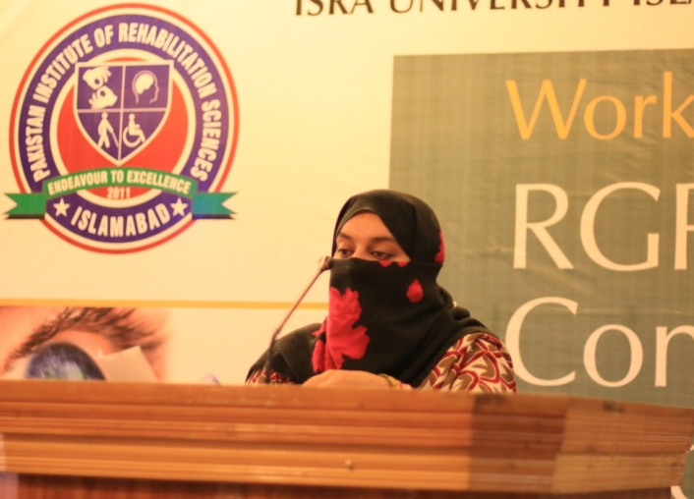
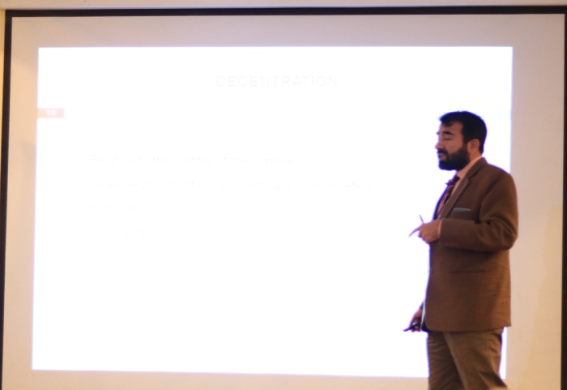

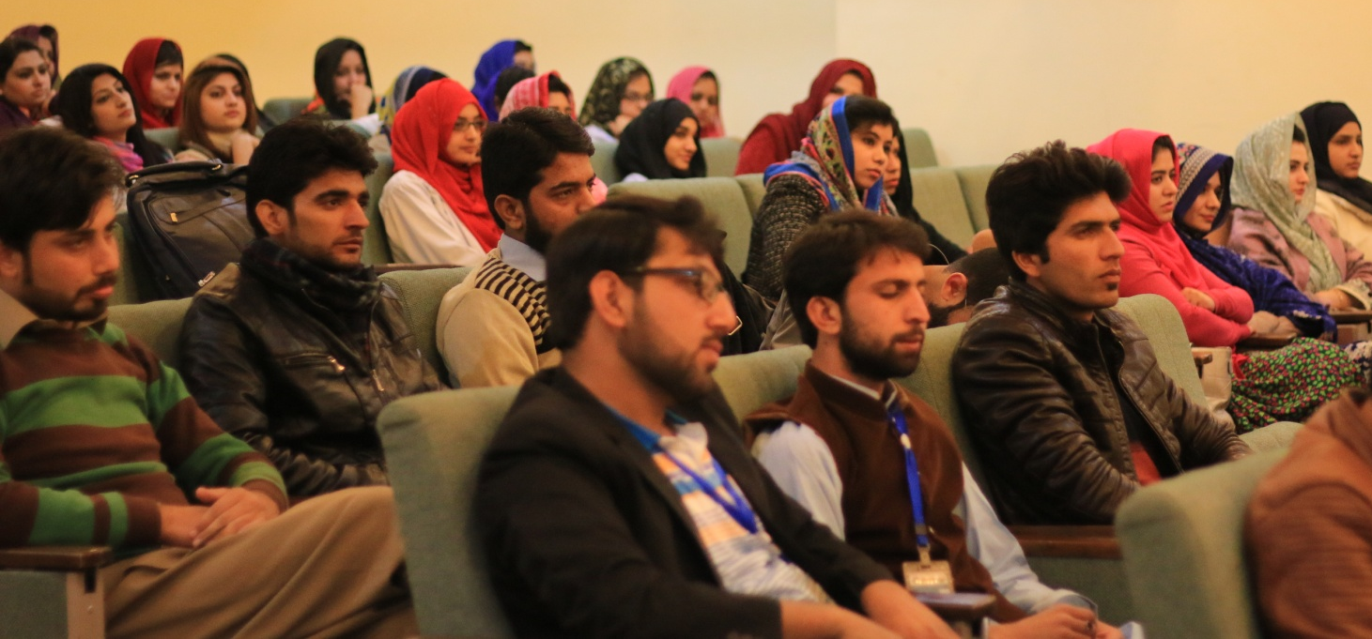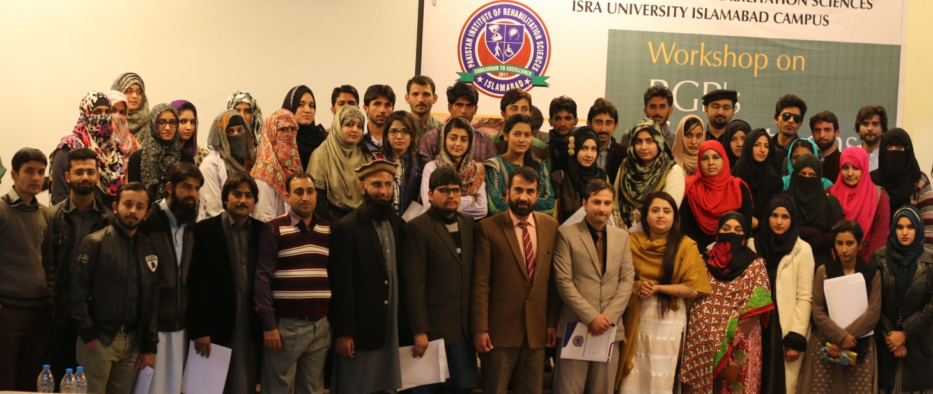
Schedule of the Workshop: (23rd December 2016)
Registration 9:00am to 9:30am
Telawat e Quran 9:30am to 9:40am
Welcome Speech by the Executive Director PIRS 9:40am to 9:55am
10:00am to 10:30am | RGP’s in Everyday Practice – An overview
10:30am to 11:00am | Do’s & Don’t in RGP Contact Lens Practice
11:00am to 11:30am | Fitting of RGP Contact Lenses
11:30am to 12:00pm | Evaluation of RGP Contact Lens Fitting
Tea Break & Jumma Prayer Time 12:00pm to 01:00pm
01:00pm to 01:30pm | Problems in fitting RGPs & its Solution
01:30pm to 02:00pm | Care & Maintenance of Contact Lenses
02:00pm to 02:30pm | Complications of RGPs & its Management
02:30pm to 03:00pm | Questions & Answers
Finances of the Workshop:
S. No: | Description | Amount (PKR)
1 | Refreshments for the Speaker & Attendees | 11,000/=
2 | Panaflex (for Auditorium) | 1728/=
3 | Certificates + Envelopes (91+100) | 6415/=
4 | Mineral Water (3) | 180/=
5 | Bank Transaction Fee (On Cheque Submission) | 377/=
 | Total Expenses without Taxes | 19700/=
 | Advance Received | 2000/=
 | Balance | 7300/=
 | Speaker Remuneration (To pay by Finance Deptt) | 10,000/=

23rd December 2016

The Executive Director
Pakistan Instt of Rehab Sciences
Isra University Islamabad Campus.

Respected Sir,
It is requested to please kindly approve the above mentioned expenses to clear the Workshop Finances of “RGP’s Contact Lens Practice”.

Thanking you Sir.

Submitted By: Submitted to: Approved By:

Muhammad Qasim Saafia Ismat Dr. Farrukh Seir
Asstt Prof – Optometry Manager Academics Executive Director PIRS PIRS PIRS

