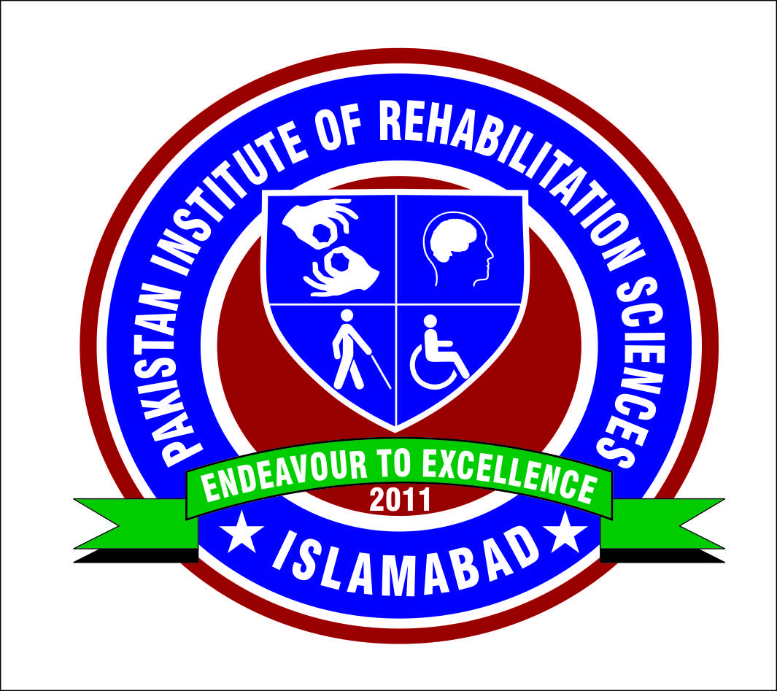 PAKISTAN INSTITUTE OF REHABILITATION SCIENCES ISRA UNIVERSITY ISLAMABAD CAMPUS
TWO DAYS HANDS-ON TRAINING ON
SYNOPSIS WRITING & DATA ANALYSIS VIA SPSS

Research - being an important component in any degree program at university level so that to widen the minds of students and get the community exposure to have a real time experience. Pakistan Institute of Rehabilitation Sciences (PIRS) is committed to provide quality human resources development and improve their skills by getting high level trainings from the expertise in the concerned disciplines running at PIRS. To develop a high impact research, one needs to have a sound research methodology, getting proper data entry and carry out the needed data analysis followed by a quality manuscript writing to produce a standard research article / paper.
Pakistan Institute of Rehabilitation Sciences (PIRS) successfully conducted two – days hands-on training workshop on “Synopsis writing & Data Analysis Using SPSS” on 11th-12th April 2017. Workshop was facilitated by one the eminent Foreign Qualified Researcher Dr. Muhammad Abdul Samad (Epidemiologist & Biostatistician) who is the master trainer for similar kind of workshops not only nationally but internationally as well. Workshop was attended by the faculty and students of Vision Sciences & Audiology departments. Workshop was very much appreciated by the students of PIRS and faculty as well. Strength of the workshop was interactive discussion and task based exercises on things to consider while synopsis writing and how to proper enter and analyze data via applying appropriate statistical tests.

Objectives of the Training:
- Synopsis Writing: Synopsis writing part of the workshop will develop skills among the students to write and develop a productive Synopsis / Research Proposal in their concerned disciplines.

- Data Analysis via SPSS: The workshop will orient you with the fundamentals of SPSS and develop skills of:
- Selection of appropriate statistical Tests
- Steps to run the selected Statistical Test
- Interpretation of Results
- Presentation of Results in the Manuscript or Thesis in the standardized format

Workshop Participants:
- Faculty of Vision Sciences & Audiology
- 8th Semester Students of Vision Sciences
- 7th & 8th Semester Students of Audiology
Workshop Format: This was an interactive, but structured training session covering the topics outlined in the programme. The workshop is designed on Task Based Instructional Design. Initially, a task on SPSS was performed by the instructor and later candidates were facilitated to perform specific task individually, on dataset saved in the candidate hard drive. Each candidate was provided with a number of datasets and specific tasks to perform. Workshop was run strictly from 9:00am till 5:00pm both the days with having small breaks for prayer & refreshments.
Workshop Facilitator:
Dr. Muhammad Abdul Samad - M.B.B.S, MPH (Aberdeen), MMED (Dundee), PGCer(Med Biostatistics)
The facilitator for this workshop was Dr. M A Samad who has done MPH from Aberdeen University, MMED from University of Dundee, and PG-Cert (Medical Statistics) from University of Cambridge. He has worked in the Health Intelligence Department and as a Clinical Researcher in NHS Grampian, UK.

Random Clicks of the Workshop held on 11th – 12th April 2017
